Admob Integration

Go to Tools-> Game Design -> Other Option

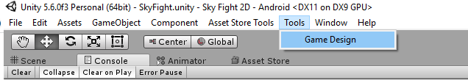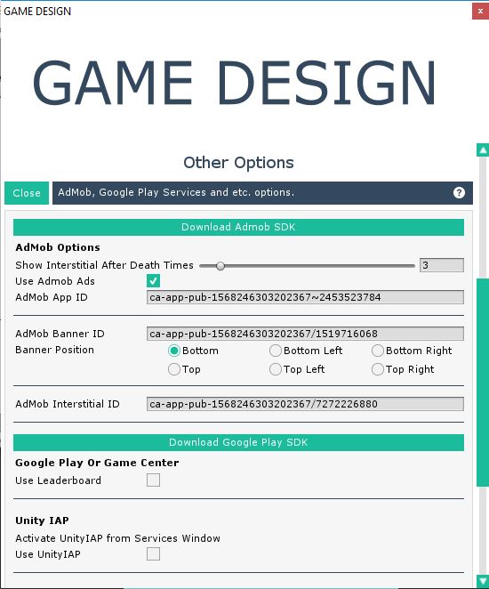

Provide the Id details App ID , Banner ID and Video ID

Select AdsManager GameObject in hierarchy and set IsTesting true and provide Device ID (only for android)

Test the app 1st

Note:- For Testing all the IDs are compulsory

Use App to find Device ID :- <https://play.google.com/store/apps/details?id=pe.go_com.admobdeviceidfinder&hl=en>

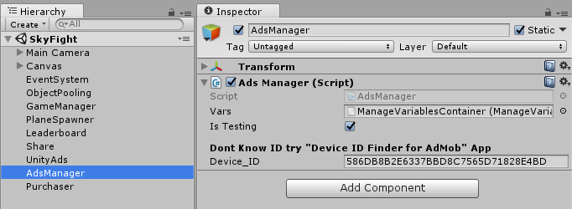

To use the ads you have 2 methods

ShowInterstitial() , ShowBannerAds().

You need to call this methods in other scripts to show ads eg: AdsManager.instance. ShowBannerAds();

AdsManager.instance. ShowInterstitial()

Put the admob code in if statement so that if player buy remove ads then it wont show.

If(GameManager.instance.canShowAds == true)

{

}